Name:Kothmirkar Keerthan
HallTicket: 2303A52008
Assginment:11.1
Batch:43
Task:01
Task Description #1 – Stack Implementation
Task: Use AI to generate a Stack class with push, pop, peek, and is_empty methods.
Sample Input Code:
class Stack:
pass
Expected Output:
- A functional stack implementation with all required methods and
docstrings.
Prompt: create stack for pop push and is empty function with dotstrings
Code:
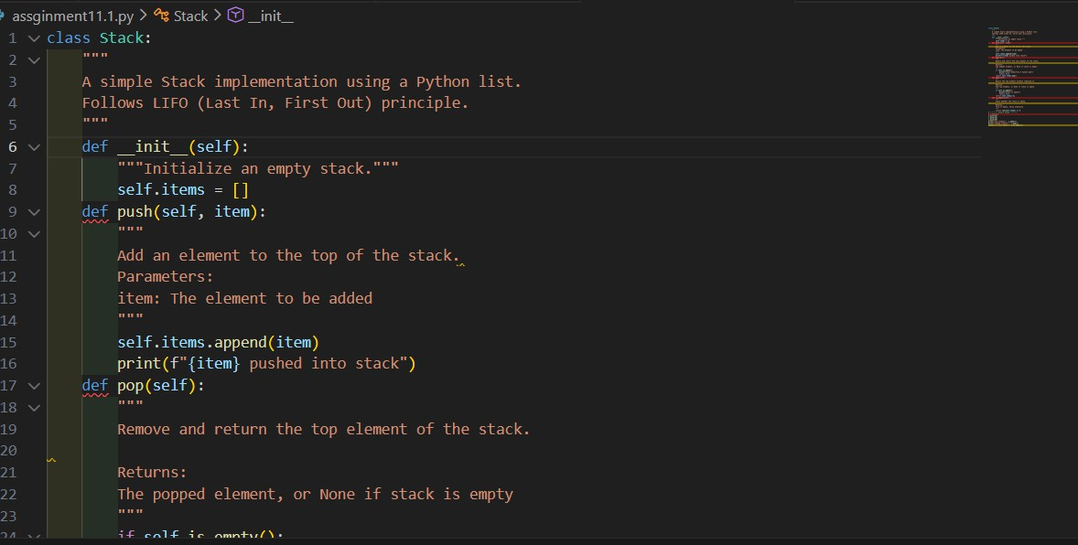

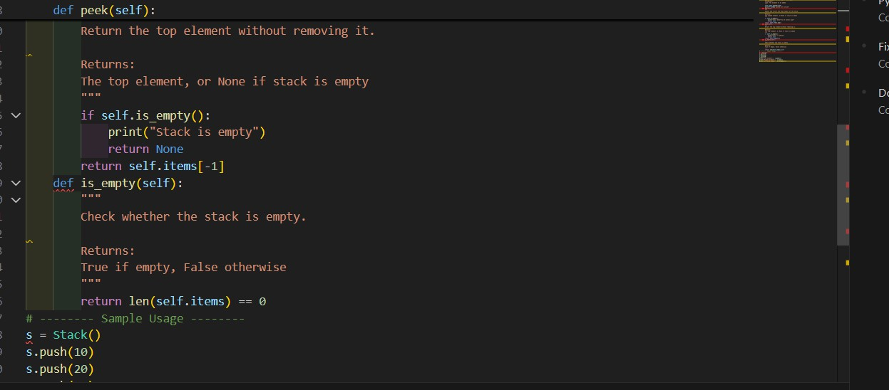
Output:
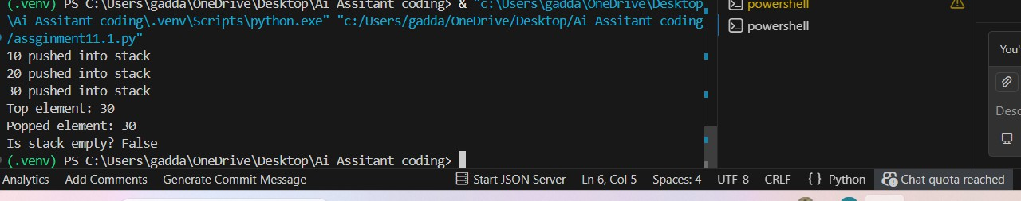
Observation:
The stack follows the LIFO (Last In, First Out) principle where the last inserted element is removed first.
push adds elements, pop removes the top element, and peek shows the top without removing it.
is_empty checks whether the stack contains any elements to prevent underflow errors
Task:02
ask Description #2 – Queue Implementation
Task: Use AI to implement a Queue using Python lists. Sample Input Code:
class Queue:
pass
Expected Output:
- FIFO-based queue class with enqueue, dequeue, peek, and size

Method
Prompt:implement Quees following the fifo deque and peek Code:
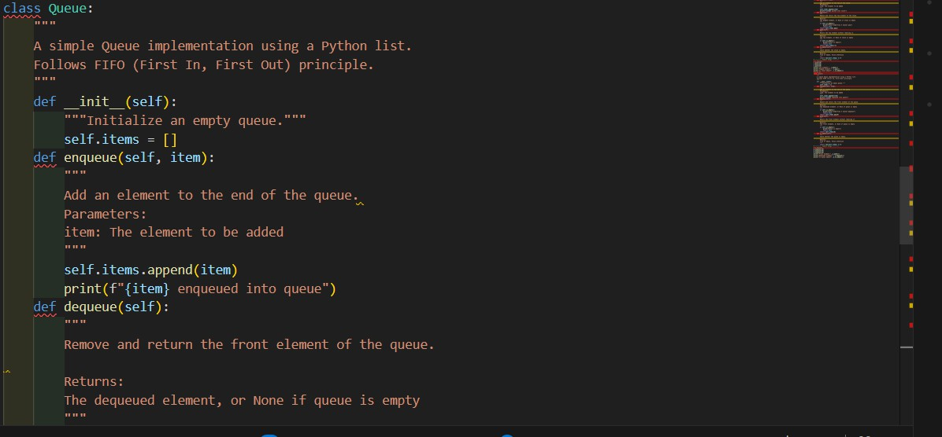

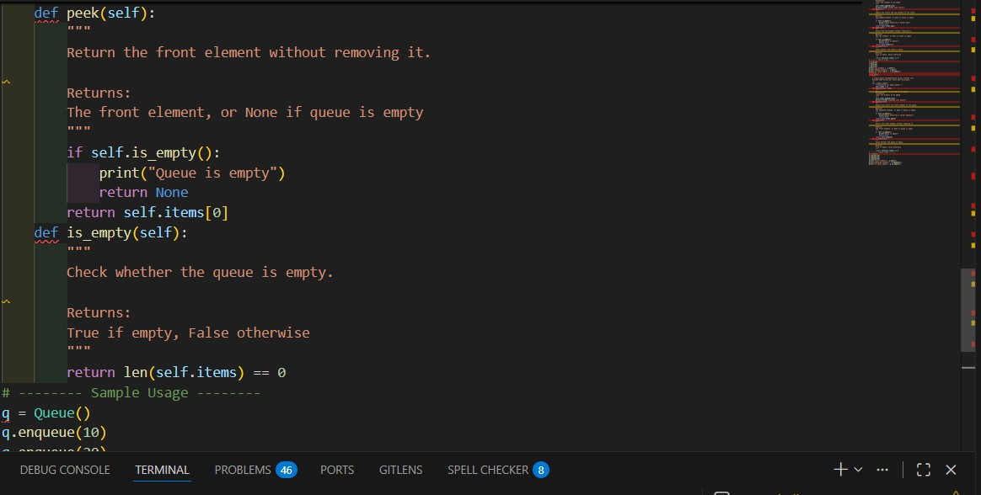
Output:
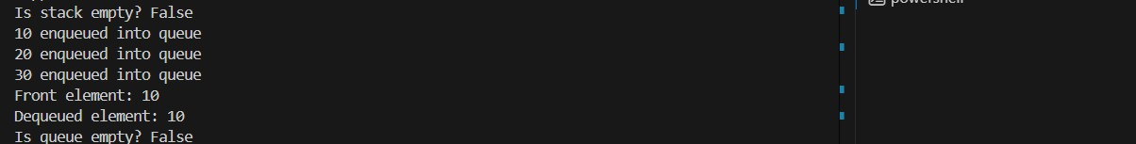
Observation:
The queue follows the FIFO (First In, First Out) principle, where the first inserted element is removed first.

enqueue adds elements to the rear, while dequeue removes elements from the front of the queue.
peek shows the front element without removing it, and size returns the current number of elements in the queue.
Task:03
ask: Use AI to generate a Singly Linked List with insert and display methods.
Sample Input Code:
class Node:
pass
class LinkedList:
pass
Expected Output:
- A working linked list implementation with clear method
Documentation
Prompt: create singleylinked list
Code :
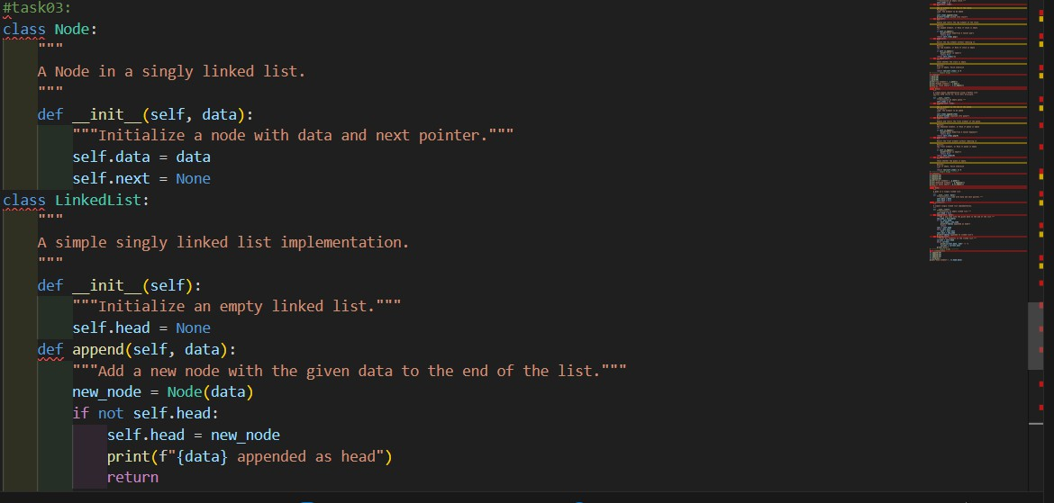

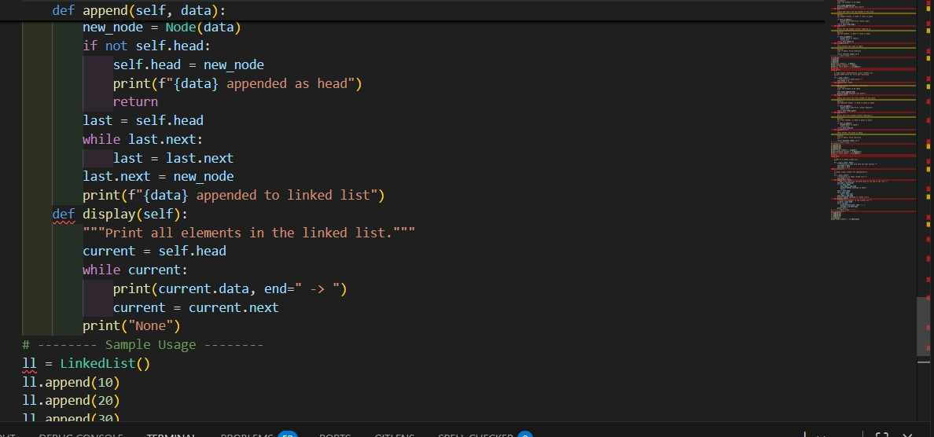
Output:
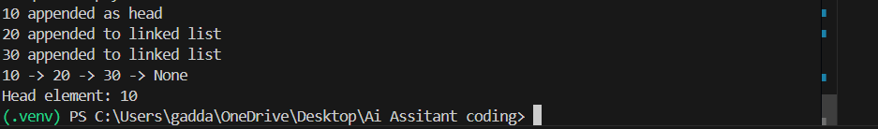
Observation:
- A singly linked list stores elements in nodes where each node points to the next node in sequence.
- The insert method adds new elements at the end by traversing the list until the last node.
- The display method prints all elements sequentially from the head to the last node.
Task:04
ask: Use AI to create a BST with insert and in-order traversal methods. Sample Input Code:
class BST:
pass
Expected Output:
- BST implementation with recursive insert and traversal methods.
Prompt: create a Binarysearch tree for the following reuirements

Code:

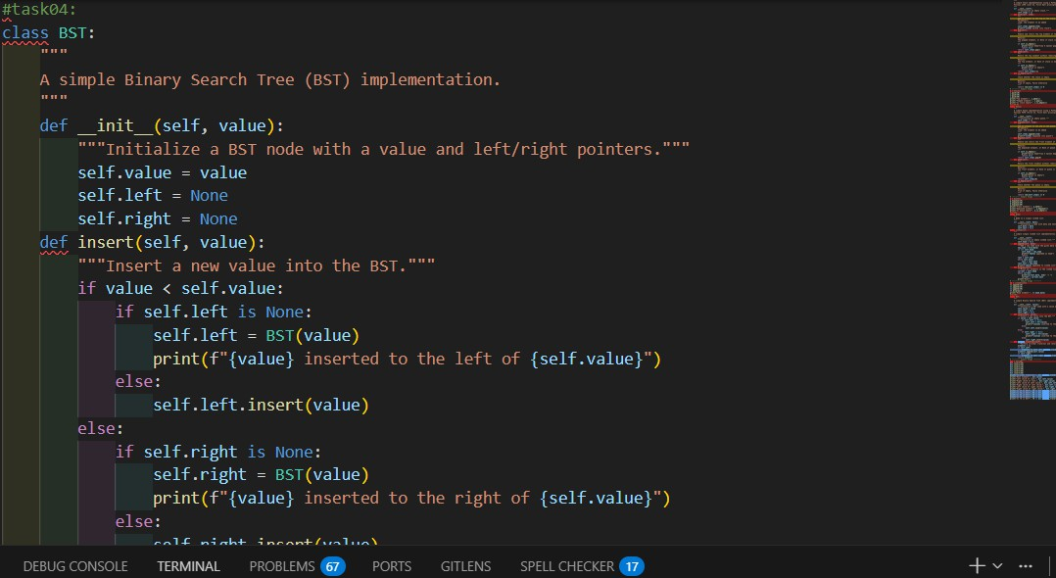
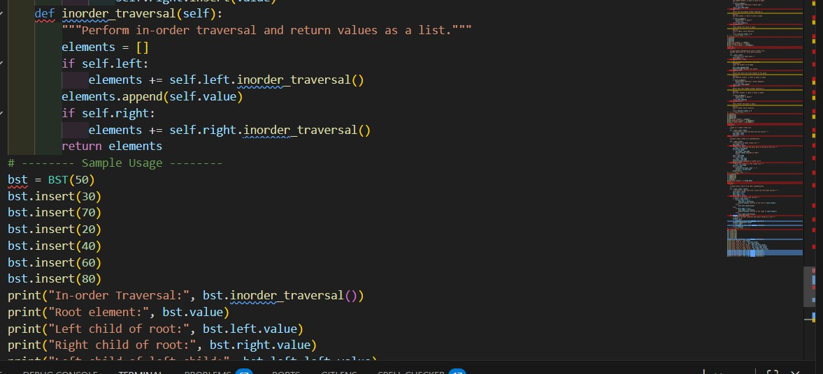
Output:

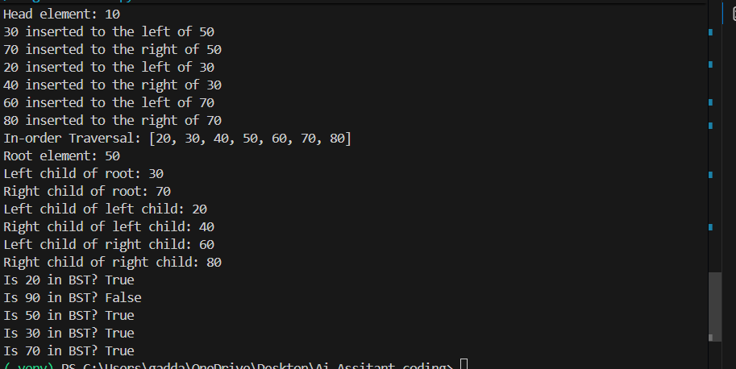
Observation:
A Binary Search Tree (BST) organizes data such that left child nodes contain smaller values and right child nodes contain larger values than the parent.
The recursive insert method places each new value in its correct sorted position while maintaining BST properties.
In-order traversal visits nodes in Left → Root → Right order, producing the
elements in sorted (ascending) order.
Task:05
ask Description #5 – Hash Table
Task: Use AI to implement a hash table with basic insert, search, and delete methods.
Sample Input Code:
class HashTable:
pass
Expected Output:
- Collision handling using chaining, with well-commented methods Prompt: implement hash Table in python
Code:

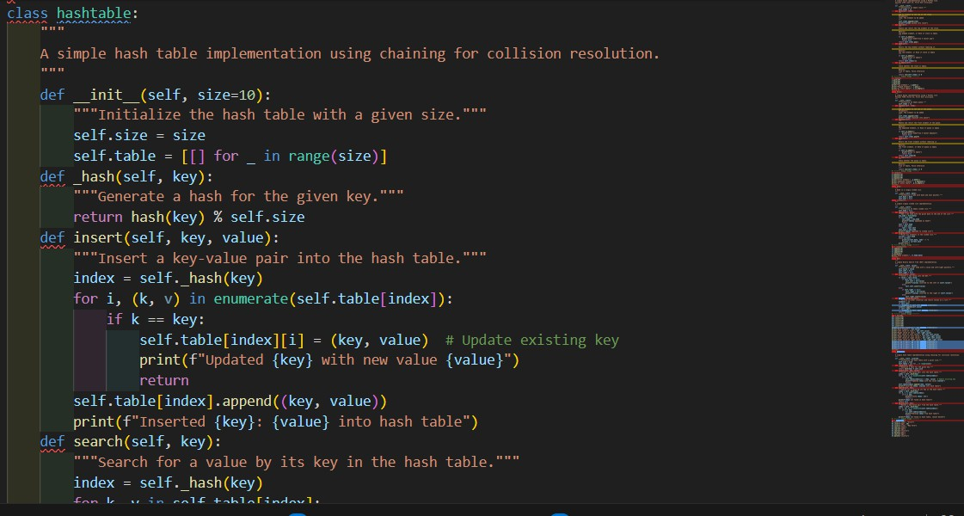
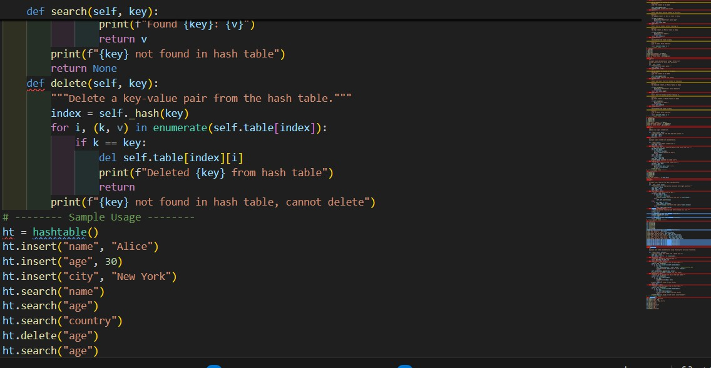
Output:

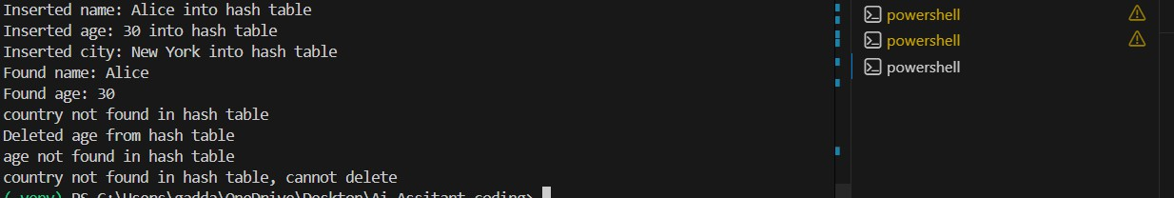
Observation:
A hash table stores data using a hash function that maps keys to specific indices for fast access.

Collision handling with chaining uses linked lists (or lists) at each index to store multiple elements that hash to the same position.
The insert, search, and delete methods operate efficiently, typically in constant time on average
Task:06
Task: Use AI to implement a graph using an adjacency list. Sample Input Code:
class Graph:
pass
Expected Output:
- Graph with methods to add vertices, add edges, and display
connections.
Prompt: create graphs my function find all the vertices add edges Code:
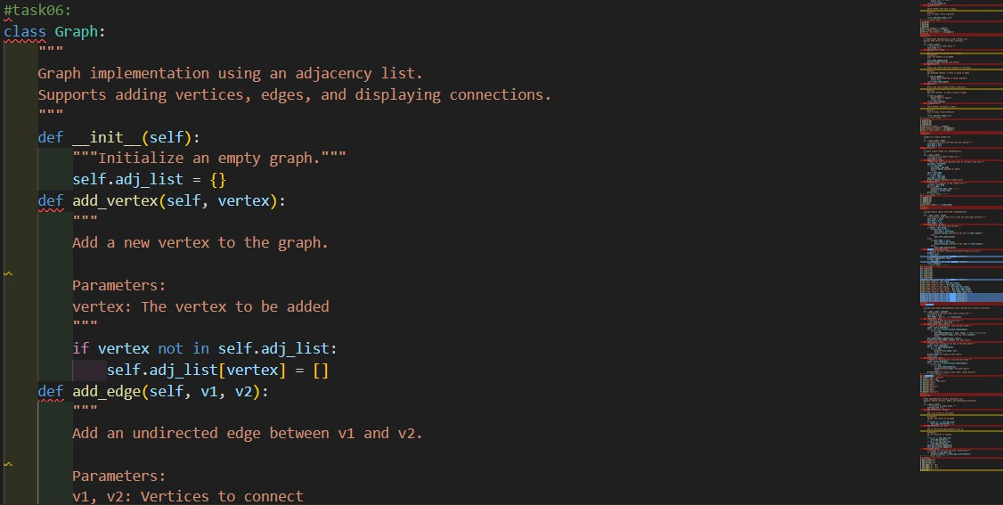

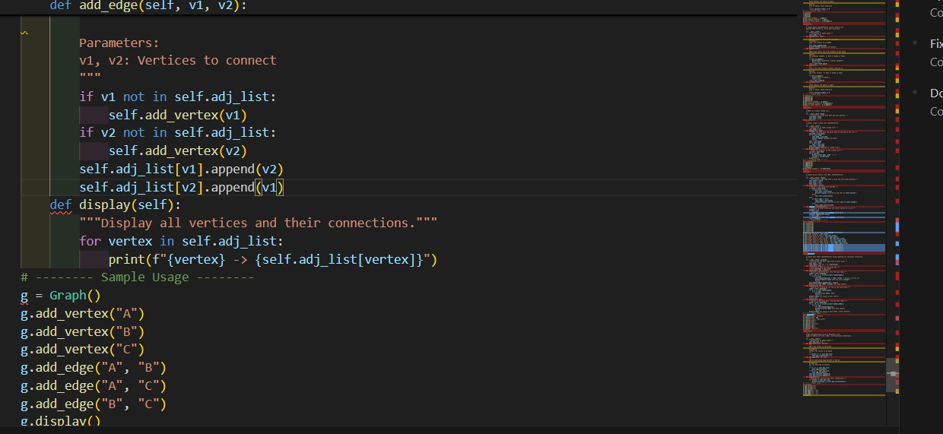
Output:
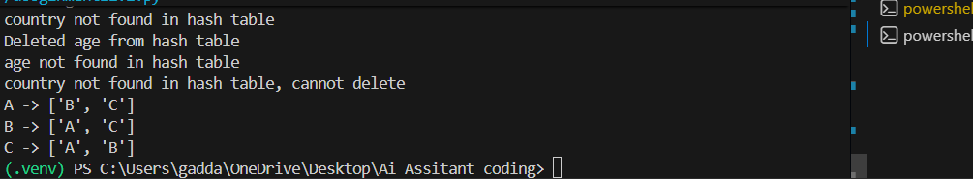
Observation:
An adjacency list represents a graph efficiently by storing each vertex and its connected neighbors.
Adding an edge updates the connection list of both vertices in an undirected graph.
This representation is memory-efficient for sparse graphs compared to adjacency matrices
Task07:
ask: Use AI to implement a priority queue using Python’s heapq
module.
Sample Input Code: class PriorityQueue: pass
Expected Output:

- Implementation with enqueue (priority), dequeue (highest priority),
and display methods.
Prompt: for this implement the priority Quee for following requirements Code:
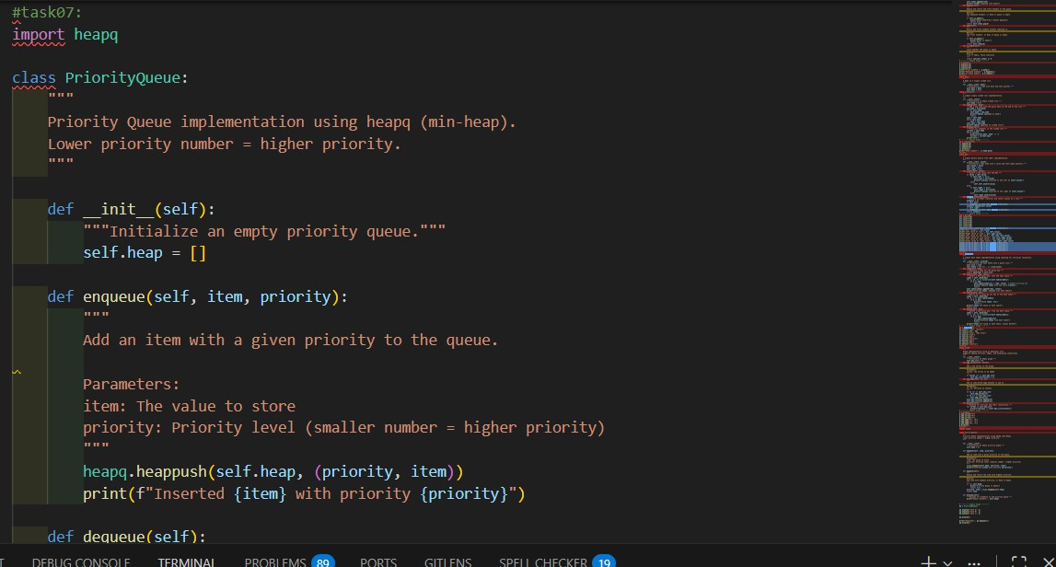
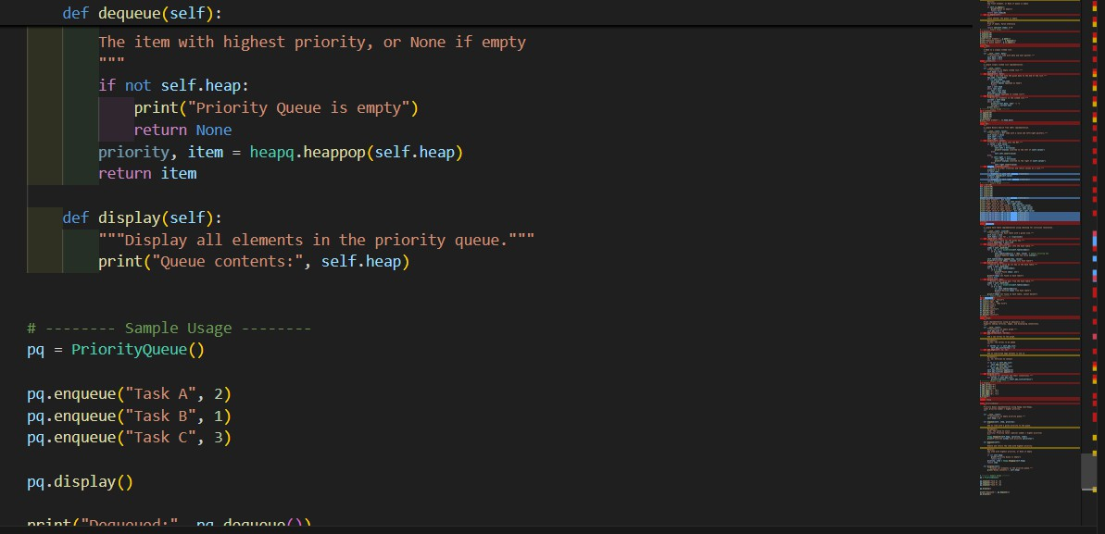
Output:
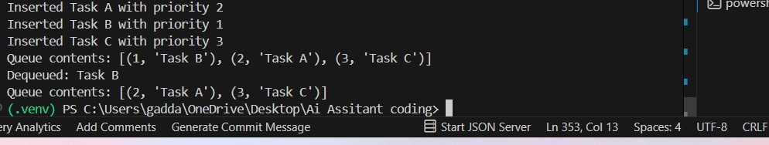

Observation:
- The priority queue uses a heap structure where elements with higher priority (smaller number) are removed first.
- The enqueue method inserts elements while maintaining heap order automatically.
- The dequeue method efficiently removes the highest-priority element in logarithmic time.
Task:08
Task Description #8 – Deque
Task: Use AI to implement a double-ended queue using collections.deque.
Sample Input Code:
class DequeDS:
pass
Expected Output:
- Insert and remove from both ends with docstrings.
Prompt:
For this implement the deque and do all the requriements Code:

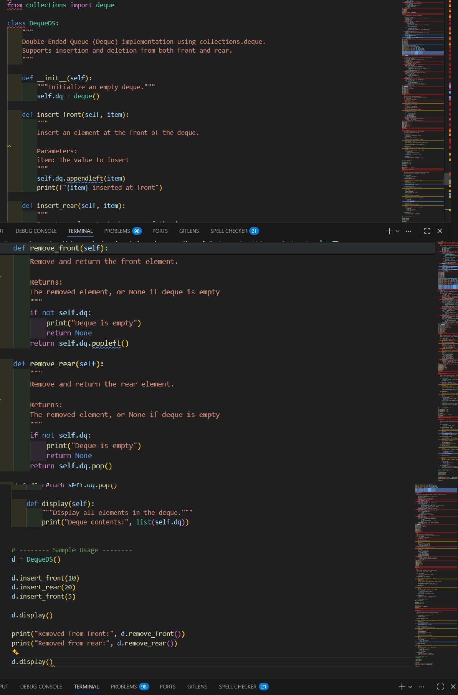

Output:

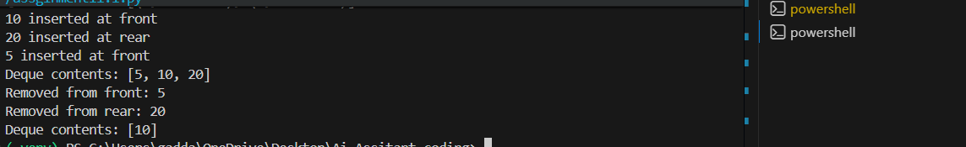
Obsrvation:
A deque allows insertion and deletion from both the front and rear efficiently.
appendleft and popleft handle front operations, while append and pop handle rear operations.
This structure is useful for applications requiring flexible queue behavior, such as sliding window problems.
Task:09
Task Description #9 Real-Time Application Challenge – Choose the Right Data Structure
Scenario:
Your college wants to develop a Campus Resource Management System that handles:
- Student Attendance Tracking – Daily log of students entering/exiting the campus.
- Event Registration System – Manage participants in events with quick search and removal.
- Library Book Borrowing – Keep track of available books and their due dates.
- Bus Scheduling System – Maintain bus routes and stop connections.
- Cafeteria Order Queue – Serve students in the order they arrive. Student Task:
  - For each feature, select the most appropriate data structure from

the list below:
- Stack
- Queue
- Priority Queue
- Linked List
- Binary Search Tree (BST)
- Graph
- Hash Table
- Deque
  - Justify your choice in 2–3 sentences per feature.
  - Implement one selected feature as a working Python program with
AI-assisted code generation. Expected Output:
  - A table mapping feature → chosen data structure → justification.
  - A functional Python program implementing the chosen feature
with comments and docstrings.
Prompt: for this implement the all the requirements of my document:
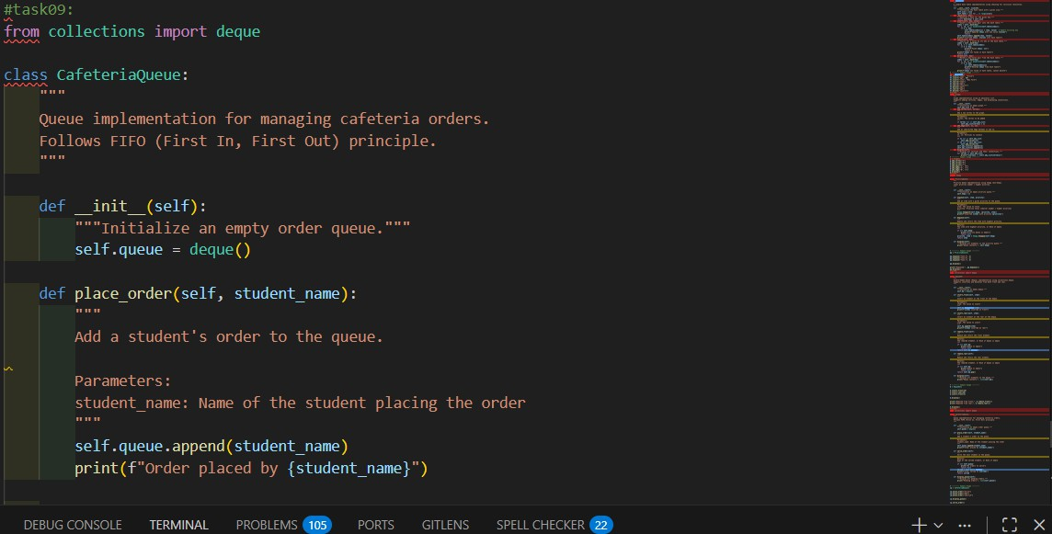

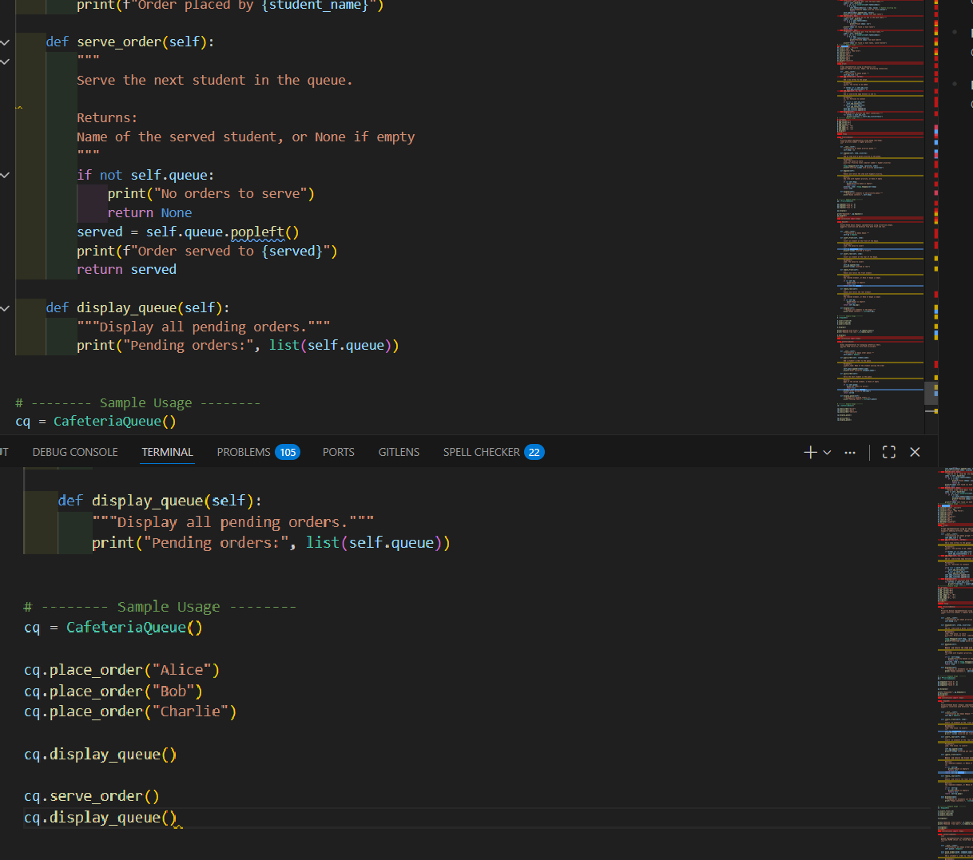
Output:
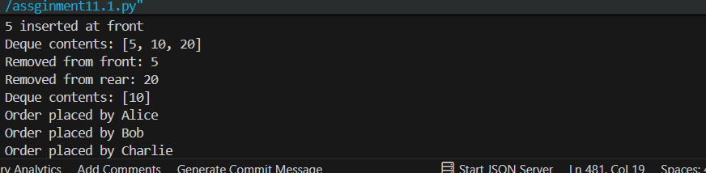
Observation:

- The cafeteria system follows FIFO order, ensuring students are served fairly based on arrival time.
- The queue efficiently handles adding new orders and serving existing ones without reordering.

- This structure is ideal for real-time service systems where order of processing must be preserved.

